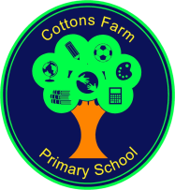
COTTONS FARM SCHOOL UNIFORM

SWEATSHIRTS (SIZES 24, 26, 28, 30/32, 34, small adult) - £8.00

CARDIGANS (SIZES 24, 26, 28 30/32, 34, small adult) - £9.50

We have most sizes in stock, but we will order for you.

BOOK BAGS - £4

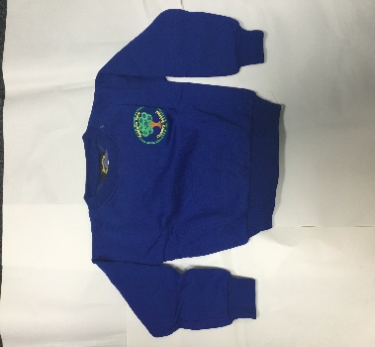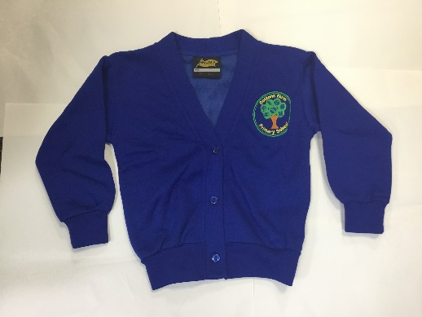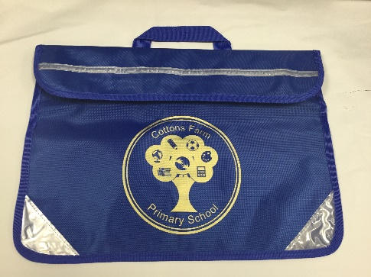
Sweatshirt Cardigan Book Bag

