Summer 2

Year 1/2

2017

2014
Mrs Hadfield

Expectations  - Children work hard and do their best at all times.  - Children have good manners and a positive attitude to learning.  - Children have reading folders with their blue books in school every day.  - Children have PE kits in school every day.  PE Kit in a drawstring bag and please remove earrings – Monday and Thursday  - Black PE shorts  - White T-shirt  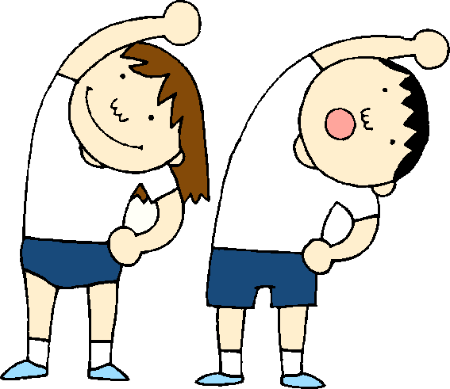  - Plimsolls/ Trainers |  |  | Summer 2 2017  English Explanations How to trap a dragon Poetry: Take one Poet poetry appreciation SPAG: Using an exclamation mark at the end of a sentence to indicate an exclamation Take one book Fantastic Mr Fox Maths Mass and capacity Arrays, Adding and sharing equal groups Problem solving and reasoning  PE  Dance, Yoga Bugs, Fundamentals through striking and fielding  Science Working scientifically-Science investigations RE In what way is a church/mosque/ synagogue important to believers? History Planes/trains and automobiles P.S.H.E Stranger danger Road safety Computers We are celebrating  Art Primary and secondary colours, Shades and Tints, Kandinsky’s circles Music Charanga – Reflect, rewind and replay  Reading Books are sent  home daily – please read  with your child at home and  return to school every day.

